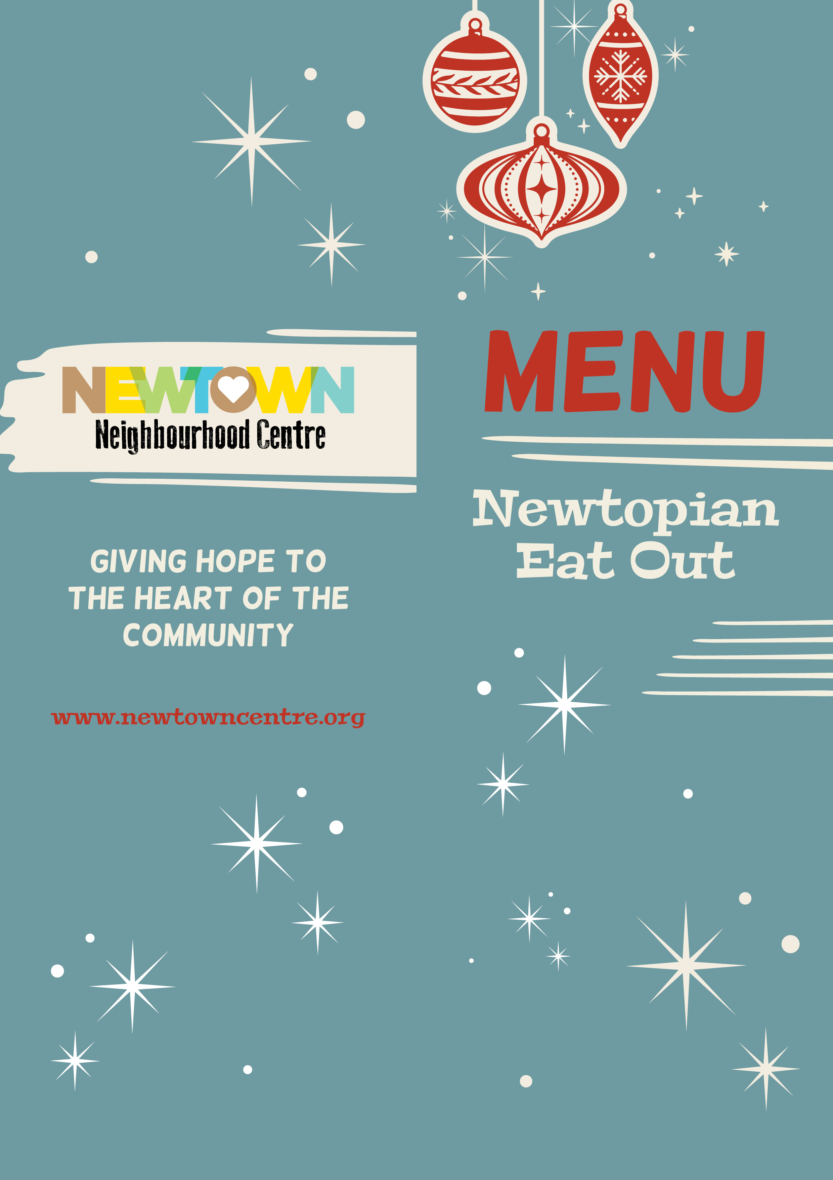

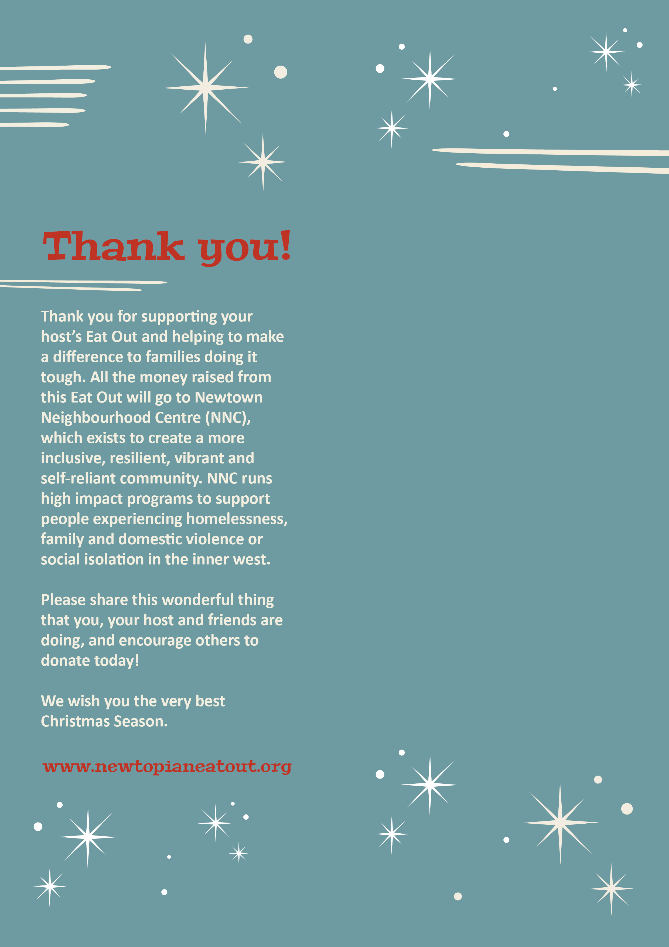

To whet your appetite...
Menu Item

To start...
Menu Item
Menu Item
Menu Item

To fill any gaps...
Menu Item
Menu Item
Menu Item

To finish
Menu Item
Menu Item
Menu Item

Additional Notes:**

