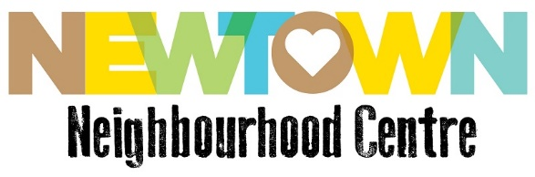
New(town) Beginnings #24

Dear Neighbour,

From a professional perspective, there is an irony that during this time of extreme physical distancing and increased isolation it has actually allowed us to extend our reach in ways we wouldn’t have thought possible before.
As a sector that is notoriously overworked and under resourced, we are used to people coming to us but rarely the other way around, unless we’re prepared to work 24 hours a day!
So while we’re busier than ever, we’ve also had time to reflect on our normal practice. If there is a silver lining it’s that the pandemic has forced us to step outside our home base and try to find those other individuals that may require some assistance. The ones who may be struggling but who never seek help.
I’ve spoken to quite a few colleagues in the sector who have reported similar experiences and we are all asking ourselves, how do we find people that our service can support?
Here at NNC we’re utilising technology to reach out to clients but the reality is, many just aren’t online. This has forced myself and the team to go back to basics: letterbox drops and knocking on doors. While it is certainly more time consuming, it is also incredibly satisfying when you speak to someone who isn’t aware that assistance is available.
As one of the key partners in the Marrickville South Collective, we did a flyer drop a few weeks ago to all the social housing residents living in South Marrickville. The flyer offered delivery of affordable food hampers as well as our contact number for additional support.
One of the residents – an endearing and friendly older woman – called us not long after receiving the flyer. She was tentative and unsure but I also recognised some hope in her voice.
“Hello young lady. First I have to say that I am a Muslim woman. I know not everyone likes us so is it ok for me to get help from you?”
It was a tragically sad introduction and I still think of it often.
The conversation flowed easily and she confided how difficult this time has been as she is on her own. She had previously lost her daughter to illness and with the current government restrictions her other son was not able to visit as he has young children.

Still, she was surprisingly ok and was excited about the prospect of fresh fruit and vegetables being delivered. She also expressed concern for her fellow neighbours and said she wanted to know how she could get help for those with mobility issues.
Since that initial call, one of our Arabic speaking colleagues from Community and Cultural Connections (CCCI) has been reaching out to her regularly. I’m forever grateful to bilingual workers who are able to deepen the connection through cultural familiarity and language.
My incredible colleagues in the Marrickville South Collective have been generously donating their time to deliver over 40 food parcels from Addison Road Food Pantry to residents in the area once a week. It is great that we are using this time as an opportunity to share information and resources like we never have before.
While we haven’t been inundated with calls from the flyer drops, in these scenarios it’s not so much about quantity but quality. The relationships we’re building are meaningful and we’ve been able to reach people who would never normally venture to Newtown for face-to-face advice.

And if we only get one call and we are able to make a difference I think it’s worth it.

Stay safe and connected,

Mel
Community Strengthening Team

P.S. – if you would like to help support the food parcels at Addison Road Community Centre, you can donate via this link.

