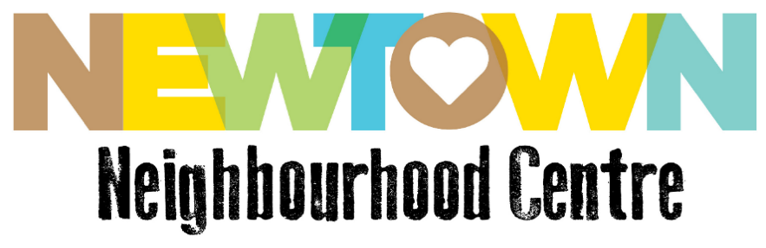
Minutes of Boarding House Roundtable Meeting, 20th November 2018
Item 1 | Present  Liz Yeo Newtown Neighbourhood Centre  Paul Adabie Newtown Neighbourhood Centre  Elizabeth Priestly WayAhead Mental Health Association NSW  Paul Clenaghan Sydney Local Health District  Elizabeth De Freitas Tenants Union  Nicole Kennedy Redfern Legal Centre  Peter Dormia Property Owners Association NSW  Mark D’Astoli FACS (Boarding House Compliance)  Luke Robinson Boarding House Outreach Service student
Liz Yeo opened the meeting, gave acknowledgement of country, explained the background of the Roundtable for new attendees, and confirmed the minutes of the previous meeting.
Objective of the roundtable are:
- To promote, encourage and support good practice management in the general boarding house sector
- To provide a forum for agencies and individuals to raise and resolve issues related to boarding houses in the City of Sydney and Inner West
- To promote and protect the health and well-being of general boarding house residents.
- To identify opportunities to increase the supply of appropriate, affordable Boarding House stock
- To advocate for policy change to address identified needs of Boarding House residents
- To advocate for alternative Boarding House models which address the changing needs and profiles of residents and in particular the growing numbers of women.
We ask “What are the areas that lead to the biggest impact on the Boarding Houses sector?”
Item 3 | Matters arising from previous meeting minutes  Are there statistic being kept around Boarding Houses in Sydney?  Elizabeth De Freitas advised that the Eastern Area Tenants Service keeps statistics on Boarding Houses (with some funding perhaps received from Waverly Council).
 | Action 1: The Boarding House Good Practise Awards 2019 shall be progressing, the details of which are to be discussed at subsequent Roundtable (today’s meeting’s focus). | In Progress
 | Action 2: The formation of Review of BH Act focus groups | On Hold
 | Updates:  Paul Adabie; A draft paper regarding Boarding House policy and strategy is being developed by the Inner West Council.  Nicole Kennedy: The Redfern Legal Centre has seen an increase in the number of registered boarding houses, but many registered properties are not operating in the model of traditional boarding houses, but are registrations as such for tax purposes, and are charging high prices, targeting international students. This trend started in the East of Sydney, and is expanding into the West.  Reports some such places have been taking money from client’s accounts without permission. | Noted
 | Boarding House Good Practise Awards 2019, Paul Adabie  Background  The NNC has been involved in boarding houses in the Inner West for 10-15 years. There is a lot of negative press surrounding the BH sector, but we know that there are good operators and BHs, and NNC wanted to recognise them, and to talk about the positive aspects of boarding house life, changing the narrative, and engendering peer support between BH operators. Hence, the Boarding House Awards 2017.  There were two committees for the awards;  *Steering Committee, with representatives from: Partners In Recovery, Inner West Council, Homelessness NSW, FACS and ACU  *Judging Panel with representatives from Community Housing, Health, Mental Health carers, A Local Church and ACU.  There were 4 nominations per category (although one BH nominee declined the nomination), and 3 categories:  *Large BHs (>13 residents)  *Small BHs (<13 residents)  *Community Building  Marketing was done via social media, and postcard mail drops at boarding houses. The nominees were visited by the judging panel to verify their DA approval, their presence on the BH Register of Fair Trading NSW. An awards dinner was held, sponsored by the Eastern Prudential Insurance Group. This dinner was well-attended, and the winners were positive, and humbled by the recognition they had received.  Challenges  - The awards highlighted that there aren’t definitions of good practise for boarding houses.  - There was considerable cost and staff time commitment involved with the Awards, especially in building the processes and committees.  - After the awards, one winner was revealed to not have the appropriate insurance for their BH (a problem, especially as a sponsor was an insurance group).  - One nomination made by FACS was a BH that had had their Assisted BH status revoked by FACS 7-8 years prior to the Awards.  - One winner was shown on the television series Filthy Rich and Homeless, with the slur of being “Crystal Meth St”, another presented poorly on a Boarding House tour.  Looking Ahead  Despite problems, the BH sector is dynamic, changing one. There was bad press after the awards, but that does not necessarily undermine the choices made during the Awards.  One winner said that the awards made a difference. Her award is on her website, and this award-winning status was used as a favourable point in a child custody claim case.  Residents are emphatic in their views that there are good and bad BHs.  The importance of recognition of the effort some BH operators are putting into their BHs.  Ideas  Paul Clenaghan:  - A disclaimer statement pre-prepared about the awards NOT being an accreditation process.  - Create a resident’s criteria, so the panel is supporting the residents’ position and values.  - Self-nomination, and self-assessment in order to do so.  - Develop a media article ahead of the Awards, explaining the aims, considerations, risks, etc, of the awards, for a point of reference later if there is negative press post-Awards again.  - Let’s look into measuring the impact of the BH Awards. Look at the time before the award nominations, in which BHs can improve themselves to the level they can be nominated. Then check the BH “level” during the Awards. Then track what happens after the awards, i.e. continued improvement, sustaining of improvement for Awards, regression. Track media coverage to this end.  Elizabeth Priestly:  - Set a judging standard, and keep to it. If the standards aren’t met, don’t just give the award to the next-best nominee.  - Consider staff time and resources  - Approach other NFPs as Awards associates.  Nicole Kennedy:  - Fundraising  - Invite residents to be part of the process to make the Awards more robust and transparent. Resident nominations.  - A category for real estate agents, since >50% of BHs are currently operated through RE agents.  - Sponsorship through a peak body.  - Gavin Coote of the ABC has been covering stories around the BH sector lately, perhaps he might be a potential promoter of the Awards.  Mark D’Astoli:  - It could be an opportunity for student placements, giving them experience, and helping with the time and work demands of the Awards.  Elizabeth De Freitas:  - Have a charter (such as that being developed by LegalAid) that operators sign, agreeing to be a good landlord.  Liz Yeo:  - A category for “Most Improved BH”.  - Do the Awards every other year, as they are costly and time consuming.  Prizes  Views range from prizes being a better incentive than recognition, to the potential for prizes to be practical contributions to the business of the BH. Suggestions could be taken from operators as to what would be a good prize.  Outcomes  Public Awareness  Encouraging reasonable standards for BHs to meet.  Encouraging improvement of quality of BHs. | In Progress
 | Paul Adabie on NNC updates  NNC is developing a peer support project, called Community Linkers.  It is about recruiting the best-placed people, who have lived experience, to assist with improving the experiences of others in BHs.  We are recruiting BH residents to be leaders and support persons for BH residents. The sponsors are Inner West Council, Westpac, and Uniting Church, enough for a 1-year project. The aim is to have a support group of 10-12 people, who shall receive training in such areas as Mental Health first Aid, and for whom the project might also provide a pathway for further development opportunities. Currently there are 6 strongly interested members, and more potential members.  Elizabeth Priestly: We (WayAhead) would be happy to provide training. | Noted
Item 7 | Close and Next Meeting  Thank you to everyone for coming, next Boarding House Roundtable will be next year.  Happy Holidays!

